Chapter 12, Solution 46.

For the wye-connected load,
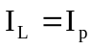, 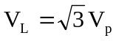 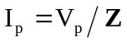
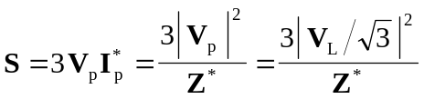
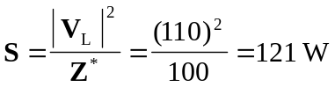

For the delta-connected load,
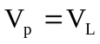, 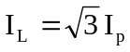,
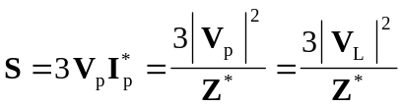
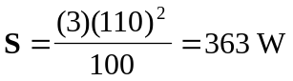

This shows that the delta-connected load will absorb three times more average power than the wye-connected load using the same elements.. This is also evident from 

